**Input and Output Problems (String and Numeric Variables)**

**Task 3:**

**Plan:**

1. Validation: check that variable carbon is an integer, if not display error message and ask to enter again.
2. Define viable hydrogen and calculate number of hydrogen.
3. Define variable chemical and calculate chemical.
4. Define variable mass and calculate atoms mass.
5. Out mass and chemical variables

**Pseudocode:**

Valid 🡸 True

While valid = True:

Try:

Carbon 🡸 input as integer ("Enter the number of Carbon atoms? ")

Valid 🡸 False

Except:

Print ("Not a valid number of carbon atoms!")

Hydrogen 🡸 (carbon*2)+2

Chemical 🡸 “C” + (carbon) + “H” + (hydrogen)

Mass 🡸 12*carbon + 1*hydrogen

Print (“The molecular mass of”, chemical, “is”, mass)

**variables table:**

|  |  |  |
| --- | --- | --- |
| Variable name | Data type | content |
| Valid | Boolean | True |
| Carbon | Integer | Stores input from user |
| Hydrogen | Integer | (carbon*2)+2 |
| Chemical | String | “C”+carbon+”H”+hydrogen |
| Mass | Integer | 12*carbon+1*hydrogen |

**Screenshot evidence:**

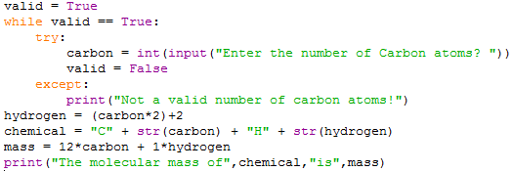

In the screenshot above, the user is asked to enter a number of carbon atoms. A while loop then validate their input so they can only enter integers. The number of hydrogen atoms, the chemical compound, and the mass is calculated and stored in 3 separate variables. Finally, the molecule mass, and chemical compound is output to the screen.

**Sample run (Output):**

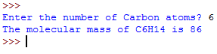in this screenshot the molecule mass, and chemical compound is output to the screen.

**Flow charts:**

Start

Yes

Is carbon an integer?

Valid = True

Carbon 🡸 input as integer ("Enter the number of Carbon atoms? ")

END

Print ("Not a valid number of carbon atoms!")

No

Print (“The molecular mass of”, chemical, “is”, mass)

Hydrogen 🡸 (carbon*2)+2

Mass 🡸 12*carbon + 1*hydrogen

Chemical 🡸 “C” + (carbon) + “H” + (hydrogen)